St. Cronan’s Junior National School

One to One Teaching Policy

Policy Summary Details

Policy Title | One to One Teaching Policy
Date Written | March 2024
Date Ratified by BOM | 22/04/2024
Review Date | April 2025

The physical structure of St. Cronan’s Junior National School allows one to one teaching to take place in a safe way for both the teacher and the pupil that is also conducive to learning.
In situations where one-to-one teaching or supervision takes place, every effort is made to ensure that it takes place in an open environment:
*Some rooms contain a glass panel on the door and windows
This allows the teacher and the pupil to see out of the room if they require assistance. In an environment where the above guidelines are not possible (e.g.: The Den, The Computer Room) the door should be kept open.
The exception is the sensory room in the exercise room – this is a solid door which must be closed for the lights to be effective. Another adult should be aware when a child/adult enters/leaves the sensory room.
Timetables are drawn up by the Special Education Teacher a copy of which will be given to the principal and will be on display in the classroom. Any work being carried out by our Special Needs Assistants will be carried out under the direction of the class teacher.
The Principal is responsible for ensuring that any visitors who are to work with children on a 1:1 basis are appropriately vetted, (e.g. HSE nurse, Psychologist, SENO etc…). Substitute teachers are Garda vetted and therefore follow the SET timetable and continue with one to one teaching as timetabled.
All children learn best in different ways and as highly trained professionals, teachers are able to adapt their teaching approach and the physical environment of the classroom to help each individual child to reach their full potential.
This policy will be reviewed as part of the Child Protection Policy each year. This policy was presented to the Board of Management and ratified in April 2024.

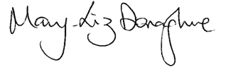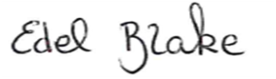

Mary-Liz Donaghue Edel Blake
Chairperson BOM Principal

