**Notification regarding the Board of Management’s review of the Child Safeguarding Statement**



To: Parents/Guardians,

The Board of Management of St. Cronan’s JNS wishes to inform you that:

• The Board of Management’s annual review of the school’s Child Safeguarding Statement was completed at the Board meeting of 22/03/2022.

• This review was conducted in accordance with the “Checklist for Review of the Child Safeguarding Statement” published on the Department’s ‘website [www.education.ie](https://www.education.ie/en/Schools-Colleges/Information/Child-Protection/mandatory-template-2.docx)

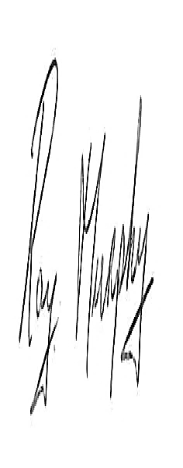

Signed __________________ Date 22/03/2022

Chairperson, Board of Management



Signed Date 22/03/2022

Principal/Secretary to the Board of Management